******The British College**

**KATHMANDU**

**Coursework Submission Coversheet**(individual coursework only)

**Faculty of Arts, Environment and Technology LBU Student Id:**

77263654

**For checking by the student:**

Please ensure all information is complete and correct and attach this form securely to the front of your work before posting it in a coursework collection box.

Award name: BSc (Hons) Computing

Module code: 14806

Module name: Production Project

Module run: 2023

Coursework title: Production project on House on Rent (Room Finder)

Due Date: 5/31/2023

Module leader: (In LBU) Patrick Ingham

Module Supervisor: (In TBC) Resham Bahadur Pun

**TURNITIN** Checked: YES NO ***(please circle)***

Submission date & time: Date: 5/31/2023 Time: 11:00 PM

**Total Word Count: Total Number of Pages (including this front sheet):**

**In submitting this form with your assignment, you make the following declaration:**  
I declare, that the coursework submitted is my own work and has not (either in whole or part) been submitted towards the award of any other qualification either at LBU or elsewhere. I have fully attributed/referenced all sources of information used during the completion of my assignment, and I am aware that failure to do so constitutes an assessment offence.

` Date: 5/31/2023

**You are strongly advised to retain a second copy of your work in case of any query about the assignment.**

63

9717

**For completion by the faculty:**

**This mark is provisional and subject to moderation and approval by the relevant examining board**

**Teacher's Feedback**

**Teacher's Signature: ______****____________________________ Date: 5/31/2023**

**Abstract**

The Room/flat on Rent (Room Finder) system was developed with the objective of facilitating the discovery of superior quality rooms and apartments. In recent decades, the advent of digital technologies has brought about significant transformations in communication methods and the utilization of digital devices in contemporary society. In contemporary times, individuals are drawn towards the adaptability and authenticity of labor provided by online platforms. Undoubtedly, the advent of smart devices has elevated our quality of life and streamlined our daily routines. The primary objective of this report is to present a conceptual overview of the processes involved in analyzing, designing, and constructing, as well as the interactions between the organization and its clients. The website was designed with the purpose of facilitating the process of locating rooms and flats in a convenient manner. The objective of the project is to provide clients with access to fulfill their specific requirements pertaining to the operations of the organization. The proposed project aims to facilitate remote access for users. Through the utilization of internet connectivity, individuals can engage in interactive communication and collaborate in decision-making processes from any location within their respective cities or across the globe. The website primarily concentrates on urban regions with high demand, such as Kathmandu, where locating suitable accommodations can be a significant challenge for prospective tenants. The primary objective of the project is to provide clients seeking accommodation with a genuine platform that offers flexibility.

**Keywords:** Room finder, Rent, vs code, Property for rent, Website, Agile etc.

Table of Contents

1.Introduction 5

2.Literature Review 6

3.Review of Technology 9

3.1 Microsoft Visual studio 10

3.2 MYSQL 11

3.3 HTML 11

3.4 CSS 13

3.5 JavaScript 14

3.6 PHP 15

3.7 Laravel 15

3.8 Microsoft word 16

3.9 Microsoft Project 16

4.Methodology 18

5.Product Design 21

5.1 Class Diagram 21

5.2 Object Diagram 22

5.3 Use Case Diagram 23

5.4 Data Flow Diagram 25

5.5 Context Diagram 26

5.6 ER Diagram 27

6. System Requirements Analysis 29

6.1 Functional Requirement 30

6.2 Non-Functional Requirement 30

6.3 Feasibility Analysis 31

7.Implementation and Testing 33

7.1 Implementation 33

7.2 Testing 38

7.3Test case for System Testing 43

8.Product Evaluation 44

9.Project Evaluation 45

10.Summary and Conclusions 47

Bibliography 48

Appendices 49

Website Screenshots 49

Meeting logs 52

Ethical Consent Form 58

Risk Register 63

**Table of Figures**

Figure 1: HTML Code 12

Figure 2:Result of HTML Code 12

Figure 3: CSS Code 13

Figure 4: Result of CSS Code 14

Figure 5: JavaScript Code 14

Figure 6:Result OF JavaScript Code 15

Figure 7: Agile Methodology 20

Figure 8:Class and Object Diagram 23

Figure 9: Use Case Diagram 24

Figure 10: Data Flow Diagram 25

Figure 11: Context Diagram 26

Figure 12: ER Diagram 28

Figure 13:Gantt Chart 32

Figure 14: Timeline 33

Figure 15: Installation of NodeJS 34

Figure 16: Installation of Xammp 35

Figure 17: Installation of Composer 35

Figure 18: Installation of Laravel 36

Figure 19: Installation of VueJs 36

Figure 20:Signup Page 39

Figure 21:Login Page 40

Figure 22:Contact Us 41

Figure 23:Logout 42

Figure 24: Task sheet 46

Figure 25:Timeline for my project 46

**List of Tables**

Table 1: Functional Requirement 30

Table 2:Non-Functional Requirement 30

Table 3:Signup Page 38

Table 4:Login Page 40

Table 5:Contact Us 41

Table 6:Logout 42

# 1.Introduction

The Room/flat on rent (Room Finder) platform facilitates the process of locating suitable cohabitants and housing options in a more streamlined and secure manner. Become a member of our authenticated community and experience increased adaptability and openness in your pursuit of a new abode. The implementation of a room finder tool is expected to streamline and facilitate the process of locating suitable accommodations. Given that flexible renting terms are becoming increasingly prevalent, we maintain that it is imperative for our users to have the option to rent their accommodations with ease and flexibility, while also having access to a diverse range of lodging options. Room Finder offers an additional level of security to individuals who are either seeking a roommate or listing their room. This is achieved through the implementation of identity verification, background checks, and payment processing, thereby ensuring the safest possible renting experience. Currently, individuals can browse for various types of rental properties such as rooms, flats, apartments, office spaces, whole buildings, and hostels within the Kathmandu region. The Room Finder platform serves to locate available rental spaces or to identify potential tenants. Individuals can locate accommodations such as rooms, apartments, flats, and other types of living spaces within the city based on their specific needs and preferences. Currently, Pokhara, Biratnagar, and other urban centers are undergoing comparable developmental processes. Users have the ability to choose the most suitable houses from a range of available options. Individuals who prefer mornings may opt to rent a house that faces east in order to appreciate the sunrise. Conversely, those who prefer evenings may choose to rent a house that faces west to enjoy the sunset. The adoption of such a mindset has not been previously considered, despite its lack of extravagance. There exist numerous unoccupied properties in Kathmandu that have remained vacant for a considerable duration. However, a significant number of individuals have been unable to locate them due to the lack of time to engage in door-to-door searches. If all properties were to become available online, it would fundamentally alter the current situation. This is the rationale behind the development of our web platform.

In developing countries like Nepal, it's hard to find a room in a place like Kathmandu that has a lot of people. So, using this situation as a starting point, we came up with the idea of making a website that has all the features a user would want when looking for a room or flat. Cities like Kathmandu are very busy because people from all over Nepal come there to work, study, or do other things. so it's not easy for those people to find places to stay in. This has become the most important thing for people who don't have family or friends to help them. If they want to look for rooms or apartments.

In the world we live in now, time and freedom are the most important things, and this is what our website is all about. Websites will be made so that people can do what they need to do with just one click or more. Under Authentication and Authorization, the user is given permission to view data, which helps solve the problem of data security. In this fast-paced world, time is the biggest problem. This tool can help you make better use of your time.

And here's another way that landlords can use our site to their advantage. If a landlord has to wait months for someone to rent a space, the landlord won't get any money from the area for a while. In this case, Room finder can find a tenant for the place in a very short amount of time. From our point of view and by living in Kathmandu and seeing how people live every day. Almost 70% of the people who live in Kathmandu aren't happy with where they live, either because they have to give up things like parking, water, the size and number of rooms, or where they live, or because they think their owners are charging them too much. We want this issue to go away. Our biggest hope is that a rental problem will be completely fixed.

# 2.Literature Review

Sharrett (1995) says that "property management system seeks to advise the establishment of an appropriate framework within which to oversee property holdings to achieve the agreed short-term and long-term objectives of the estate owner and specially to take into account the purpose for which the estate is held" [2]. The most important things will be to do things like negotiate leases on fair terms, start and negotiate rent reviews and lease renewals, keep an eye on physical upkeep, and make sure lease terms are followed (Michael, 2003). Property management is a difficult job that takes a lot of knowledge, skill, and the right technical and organizational skills, as well as money, to keep and increase the value of a property until it is no longer useful (Huang, 2000). Land and buildings, which are examples of property assets, are important resources for all kinds of groups, including local governments and the central government. The property resource helps these organizations succeed in the same way that other resources, such as people, money, and knowledge, do. (Rhodes, 2008). "These activities will take place within an agreed-upon strategic framework, where it is important to keep in mind the need to upgrade and merge interests where possible, recognize other opportunities for the development of potential, and fulfill the owner's legal and social duties to the community" (James and Donald, 2000). Not only is a lot of money put into these assets, but they can also add value to an organization if they are managed well and sometimes in creative ways. The lack of a strategic approach to property management and the fact that property users and operational decision makers don't recognize the value of these assets are two of the biggest problems with poor management practices (Huang, 2000). However, many organizations, both inside and outside, have responded to the problems and taken steps to improve their management practices.

The objective of this project is to develop a website utilizing VueJS as the front-end framework and Laravel as the backend framework, which facilitates users in searching for and leasing apartments, houses, and rooms. The website's search system allows users to efficiently filter and locate their desired lodging based on various criteria such as location, price, amenities, and personal preferences. The system is designed to be user-friendly and effective. The objective of this project is to establish a reliable and easy-to-use platform that simplifies the rental process for both lessees and lessors. The aim of the project is to develop a comprehensive and user-friendly online platform for locating rooms and apartments. The goal is to streamline the rental process and enhance its accessibility to a wider audience.

Here are the most important goals of this project:

1. Make a search tool that is reliable and easy to use and set up a safe way to book and pay.

2. Help tenants and owners build trust by letting them rate and review each other

3. To give complete and quick service to customers.

4. To add to the quantity of safe, high-quality rooms that are affordable.

5. Make sure the system is scalable and easy to manage while giving users an easy-to-use and aesthetically pleasing experience.

6.To learn about APIs and how they are put into place.

The Scope and limitation for this project are:

Since this website is made for people who are looking for something, it will have the following benefits:

1. They can find out more about their needs and wants.

2. They can also book both rooms and apartments at the same place.

3.People can book rooms and flats anywhere in Nepal. This can help Nepal's digital businesses grow and give its people more freedom.

4. Since this is a place for working from home, job seekers can spend less time on it, which helps them manage their time better for their own goals.

4. Scammers and fraudsters have been taking advantage of a lot of people in the name of the room-searching process and platform. This is what led to the decision to get rid of it totally in our country.

6. This major website is also set up by the country, which helps bring down the unemployment rate and keep the economy in balance in some ways.

Even though it can only be used in certain ways, they are:

1. Users should be able to connect to the internet.

2. Users should carefully read the text before moving on. This means that the money can't be returned after data and information from the database have been asked for.

# 3.Review of Technology

As Nepal there are few similar websites as of my room/flat on rent (room finder). All these websites differ from each other and have their own pros and cons. They all provide different property and user can have different experience as each website have unique features. Some of the website are Listed below:

1.Gharbheti.com:

Gharbheti.com is a website that aims to change the way people usually rent and buy buildings, flats, rooms, spaces, apartments, hostels, and land all over Nepal. People can look for and book properties from a list of available properties through this portal. The properties are listed in categories so that clients can look for the one that is best for them in terms of price and area. They search for properties by hand and urge property owners to post detailed information about their properties online.

2.Mero Real estate:

Mero Real estate is a website which is easy to use and gives you all the latest ads, market trends, and news about real estate. You can look for properties based on where they are, how much they cost, and other factors. You can also look at detailed information and pictures for each listing. But their interface is difficult to understand and have very low reviews.

3.Kotha Bhada:

Kotha Bhada is the best real estate website in Nepal to rent homes and businesses. It is Nepal's most popular site for finding homes. Kotha Badha Rental wants to make it easy for users and owners to meet each other's needs.

4.Nest Away:

It is a India based website which is one of the commonly used in India as it better and have one of the best interface and best review among the customers and clients. But it has difficult interface and Location of property is not accurate all the time.

5.Roomster:

Roomster is a site for renting rooms that works all over the world. It has listings for rooms and shared accommodations in many different places. It is easy to use and has accurate and detailed information. It also offers a variety of property and have user friendly interface.

Now a different technology is used to make this website. As for my website Vuejs and Laravel is used to make both frontend and backend. Integrated Development Environment (IDE) tools are also used to make the website listed above like Vs code, Phpstrom, Sublime Text etc and for the programming language Java, Javascript, Python, Angularjs, Vuejs, C++, C etc. So for my website I have used Vuejs and Laravel for my frontend and backend. So, by using Vue.js and Laravel, my website can give users the best experience, which makes it easier and faster for them to find and rent a room/flat. The smooth integration of these technologies allows for more advanced searching and filtering, updates in real time, safe user authentication, and easy management of property listings. Vue.js and Laravel can take your house rental platform to new levels of functionality and user satisfaction, whether you are a renter looking for your dream home or a property owner who wants to show off your rental ads.

Different tools, applications and technologies have been used in this project. And all of them are discussed below:

## 3.1 Microsoft Visual studio

Microsoft Visual Studio is an Integrated Development Environment (IDE) that can be used to make GUI dashboard, web application, web apps, mobile apps, cloud, web server, etc. Developers may construct websites, web apps, online services, and mobile apps all inside the confines of Visual Studio. It is an effective tool that facilitates a smooth editing and debugging process. Collaboration between programmers is facilitated by the Visual Studio IDE. It offers helpful tools for constructing code, and you may add on to it. This provides real-time visibility into the activities of your coworkers, allowing you to eliminate unnecessary duplication of effort. It contains a debugger, code completion with syntax highlighting, and an artificial intelligence coding model to aid with programming. Since its release over 25 years ago, Visual Studio has amassed a wealth of documentation and community support. There are hundreds of addons that can accomplish everything from integrating GitHub to provide a robust productivity boost. It's the go-to IDE for C++ developers, and it's free to boot. You can find other developers to talk to and perhaps meet up with in specialized online groups. With this kind of back-up, you can feel confident asking anything you need clarification on.

## 3.2 MYSQL

It is an open-source SQL-based (RDBMS) that is backed by Oracle. MySQL works on Linux, UNIX, and Windows, among other systems. MySQL can be used for a lot of different things, but it is most often used for web tools and online publishing. MySQL is a key part of LAMP, which is an open-source business stack. LAMP is a web development platform that uses Linux as its operating system, Apache as its web server, MySQL as its relational database management system, and PHP as its object-oriented coding language.

## 3.3 HTML

Hyper Text Markup Language is what HTML stands for. It is a fairly simple language that lets programmers build a website's basic structure. Even the most complicated websites are based on HTML. It is also the second most popular computer language used by developers.HTML uses "elements," which are also called "tags," to show things like the start of a new paragraph, making a font bold, or adding a picture caption. So, it controls how a webpage looks, how the text is split and formatted, and what the user sees. HTML's main selling point is that it's a simple and straightforward language. It's simple in structure and open to change. HTML's abundance of formatting tags makes it a breeze to create a professional-looking presentation. Thirdly, as a markup language, it allows for varied approaches to both the visual and textual elements of web page creation. Fourth, it makes it simpler for developers to insert a link into a webpage (using the anchor element in HTML), which in turn piques the user's curiosity and keeps them engaged in the experience. It's cross-platform in the sense that it can be viewed on any operating system, be it Mac OS X, Linux, or Windows and allows the developer to incorporate multimedia elements like pictures, movies, and music into the website.

.

Figure 1: HTML Code

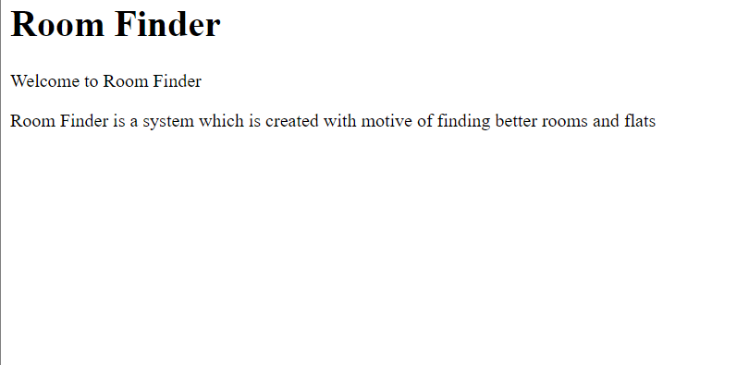

Figure 2:Result of HTML Code

## 3.4 CSS

If HTML is a website's framework, then Cascading Style Sheets is its form and function. CSS, or Cascading appearance Sheets, is a language used to define the visual appearance of various elements on a website. In other words, it's a means to spruce up and further format what you've created with HTML. If you've used HTML to insert header text, for instance, and you'd like to make that text more aesthetically pleasing by changing the font, the background color, or some other formatting aspect, you can do so. For this purpose, we have CSS. CSS also facilitates responsive web design, which ensures that your pages will look great regardless of whether they are being viewed on a mobile device, tablet, or desktop computer.

Figure 3: CSS Code

Figure 4: Result of CSS Code

## 3.5 JavaScript

JavaScript is a programming language that is object-oriented and has a low weight. It is utilized by numerous websites to script webpages. The programming language in question is a fully-featured interpreted language that facilitates dynamic interactivity on websites when utilized in conjunction with an HTML document. JavaScript enables the development of contemporary web applications that facilitate direct interaction without necessitating page reloading. JS is utilized in conventional websites to offer diverse forms of interactivity and ease of use. JavaScript serves as the scripting and query language for databases such as CouchDB and MongoDB, in addition to its utilization in web browsers.

Figure 5: JavaScript Code

Figure 6:Result OF JavaScript Code

## 3.6 PHP

PHP is an HTML-integrated server-side programming language. It is used to construct whole e-commerce sites, as well as to manage dynamic content, databases, and session monitoring. MySQL, PostgreSQL, Oracle, Sybase, Informix, and Microsoft SQL Server are only some of the supported databases. Compiling PHP as an Apache module on the Unix side makes for a pleasantly quick execution time. After the MySQL server has been established, even the most sophisticated queries that produce massive result sets are processed in a flash. In other words, PHP can create, open, read, write, and close files on a system. Forms are no problem for PHP, which can read and write files, send data via email, and display the results to the user. PHP is used to create, delete, and alter database records. Get and set variables in cookie files. With PHP, you may limit who can see certain parts of your site. It has the ability to encrypt sensitive information.

## 3.7 Laravel

Laravel is a popular PHP framework because it is both powerful and straightforward. The structure is like that of a model-view-controller. Laravel makes it easier to build a web application by reusing code from other frameworks. The resulting web app design is more organized and functional. Laravel provides a comprehensive feature set by combining the core aspects of popular PHP frameworks like CodeIgniter and Yii with those of other languages like Ruby on Rails. Laravel's extensive toolkit of features will hasten website creation The initial stable release of Laravel was in 2011, although it received little fanfare. New features, such as Artisan CLI, helped boost Laravel's profile when version 3 was released in 2012. The following are just a few of the many reasons why Laravel has become the de facto standard for PHP web frameworks. When developing web applications, Laravel encourages developers to follow the MVC paradigm. This pattern defines a set of guidelines for developing robust and easily maintained web applications.Using the Model-View-Controller (MVC) design in Laravel, programmers can standardize previously disorganized code. The MVC methodology greatly simplifies the creation of both compact and massive web applications. Laravel has preconfigured authentication and authorization components. You may implement secure authentication and authorization in your web project with just a few Artisan commands.

## 3.8 Microsoft word

One of the most popular products that Microsoft Corporation has to offer is called Microsoft Word. The initial version of this text-processing software was made available for purchase in 1983. Documents can be read, written, and edited with this application, which is compatible with the MacOS, Windows, Android, and iOS operating systems. Moreover, Microsoft Word is equipped with an integrated lexicon for the purpose of verifying spelling accuracy, whereby incorrectly spelled words are indicated by a red wavy underscore. Microsoft Word provides users with text-level functionalities such as bolding, underlining, italicizing, and strike-through, as well as page-level features such as indentation, paragraph formatting, and justification. Microsoft Word exhibits compatibility with a plethora of software applications, with the most prevalent being the other constituents of the Office suite.

## 3.9 Microsoft Project

Users of the project management software known as Microsoft Project are able to create schedules and plans for their endeavors, as well as manage resources and monitor the passage of time (Keupp, 2022). MS Project provides management professionals with access to a variety of useful tools, including Gantt charts, Kanban boards, and project calendars. A project's preliminary planning, resource management, and timesheets can all be done with this tool.

The development of websites for locating rooms and flats utilizing Laravel and the JavaScript framework is a subject of interest. VueJS has emerged as a popular and prosperous enterprise within the real estate industry. The proliferation of internet and mobile technology has led to the emergence of online rental marketplaces as the favored choice for tenants and landlords seeking to acquire and dispose of properties. The combined utilization of Vuejs and Laravel frameworks presents a formidable amalgamation that has the potential to enhance the platform's overall usability and user experience.VueJS provides a robust and efficient frontend framework for constructing dynamic and interactive web applications. The utilization of powerful features such as data binding, dependency injection, and modular architecture facilitates the development of advanced user interfaces by developers. In addition, VueJS boasts a substantial and dynamic community of developers, ensuring consistent maintenance and enhancements, thereby establishing it as a reliable choice for web development.

Laravel is a widely recognized and esteemed backend framework that provides a dependable and secure structure for the creation of web applications. This software is widely recognized for its user-friendly interface, ability to adapt to changing needs, and capacity to achieve high levels of efficiency. The utilization of the Model-View-Controller (MVC) design pattern in Laravel architecture facilitates the preservation of a clear separation of concerns and fosters the promotion of code reusability.

The amalgamation of these two frameworks will enable the creation of a platform that is both efficient and secure, while also being responsive, user-friendly, and highly functional. The platform may offer a full solution for both tenants and landlords with a variety of features like search filters, secure payment channels, user and property administration tools, and review and rating systems.

In addition to the aforementioned tools, the present project utilized a set of system requirements, which are outlined below:

Laptop: Acer Nitro 5

Operating System: Windows 10

Processor: Intel(R) Core (TM) i7-10750H CPU @ 2.60GHz 2.59 GHz

RAM: 16 GB

Graphics: Nvidia GTX 1650

# 4.Methodology

The agile methodology prioritizes the consistent delivery of work, fostering teamwork and adaptability. The process involves breaking down the project into smaller, more manageable tasks and incorporating regular feedback and iterations. By enabling greater flexibility and adaptability to change, this approach guarantees timely and budget-compliant delivery of the project. The efficacy of an agile methodology is contingent upon consistent communication and collaboration among developers, designers, and stakeholders, as it ensures alignment with the project's goals and objectives.

The iterative and incremental nature of the agile software development technique places a premium on the following four fundamental principles:

• Interactions between individuals and teams over strategies and tools

• Focus on producing fully functional software rather than extensive documentation

• Working together with the customer to negotiate the terms of the contract

• Placing a higher value on flexibility than on strict adherence to a predetermined strategy

The agile methodology takes a client-centered approach to development, encouraging them to weigh in on everything from initial concept development and project planning to iteration process prioritization, retrospective analysis, and feature development.

When compared to the conventional design approach, in which each stage of the process is only known by the expert in charge of that stage, it is clear that the former creates a more conducive environment for the project as a whole, as all procedures are known and all methods are stated clearly. Someone in charge of one phase of design on a website development project, for instance, cares primarily about his own phase. The same holds true for the testing and development phases.

Instead of trying to produce the finished product all at once, the agile methodology delivers incrementally growing versions of the product throughout the project. In contrast to the Waterfall approach, which separates the development and testing phases, Agile approaches both phases simultaneously. In agile, tasks are broken down into smaller pieces of user functionality, then scheduled and completed in iterations or sprints of two to four weeks in length.

Agile development teams typically do not use the more common practice of creating apps with a single, unified framework. Instead, tasks are broken down into smaller, more manageable chunks of code called features or microservices, and the project timeline is broken down into shorter time periods called sprints, the goal of which is to complete the full delivery process for a single feature. Developers will collect requirements for the feature in question, then design and code it, test it, seek input from customers, and test for problems before finalizing the code in each sprint. Therefore, Agile development teams may better tailor their design and coding decisions to the needs of the client by collecting input from them at various phases of the software development process. Iterating on things that have previously been released and figuring out which features to construct next can all benefit from customer feedback. The potential for a project's failure can be mitigated by adopting an Agile approach. To make sure that the quality and value of new additions are always up to par with customer expectations, it is important to collect feedback from customers on a regular basis.

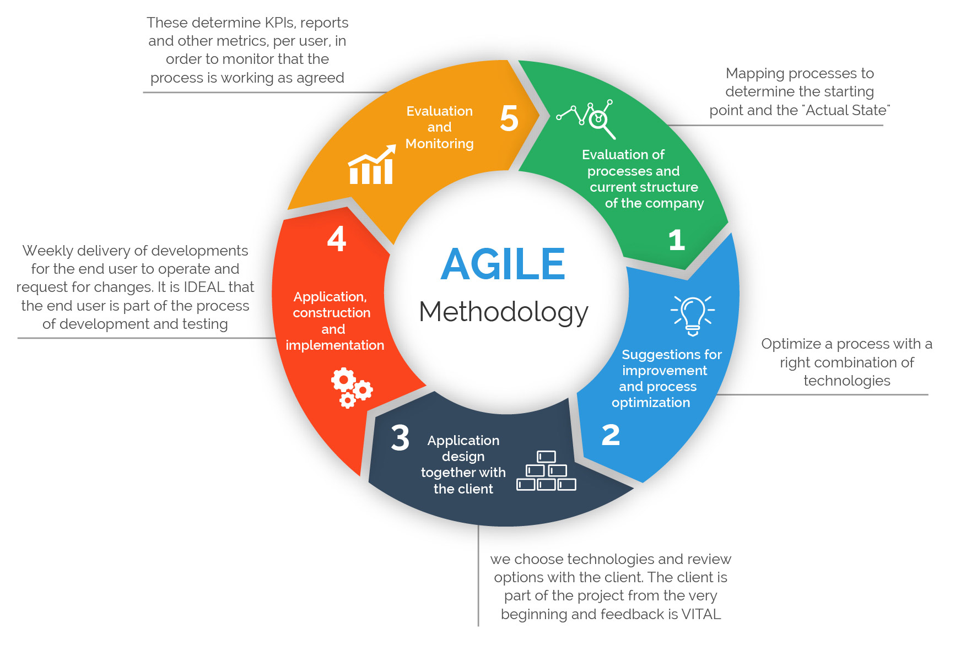

Figure 7: Agile Methodology

The management of agile projects offers a number of benefits, some of which are listed below:

1.Improved Quality: Because testing is integrated at every stage of project development, the team is able to conduct frequent inspections and locate areas in need of enhancement, which contributes to an increase in the product's overall quality.

2. Less risk: Using agile project management almost completely eliminates the possibility that a project would be unsuccessful. The functional in sprints methodology enables teams to either construct a product that is already functional from the beginning or fail quickly and try again.

3.Clear Project Picture: Agile project management ensures that team members are always up-to-date with the progress of the project. Regular scrum meetings and sprint reviews provide great opportunities for the team to enhance their visibility and stay on track towards achieving their goals.

4. Enhanced Project Management: Throughout the project, team members have increased autonomy and flexibility to experiment and fine-tune.

5.Improved Project predictability: By breaking the project into smaller sprints, project managers can accurately forecast the cost, timing, and resource allocation required for each sprint.

6.Improved productivity: Agile teams are known for their exceptional efficiency. Agile teams have a collaborative culture which leads to a significant increase in efficiencies.

# 5.Product Design

The process of software design involves the creation of a description of a software artifact with the aim of achieving specific goals through the use of predetermined components while adhering to certain limitations. The incorporation of design is a crucial factor in enhancing the efficacy of the software development process. It serves as a fundamental component of the project, providing a comprehensive understanding of its functionality and other pertinent details. This section presents an overview of the design and operation phases of the application. The desktop application known as the emotion-based music player enables users to access personalized playlists and listen to music that corresponds with their present emotional state. The subsequent design employed in this project is as follows:

## 5.1 Class Diagram

The class diagram is a type of diagram that represents the static structure of a system. This statement denotes the depiction of an application's static perspective. The class diagram serves not only as a means of visually representing, describing, and documenting various facets of a system, but also as a tool for generating executable code for the corresponding software application. The primary objective of a class diagram is to represent the unchanging perspective of a software system. Class diagrams are a type of diagram that can be directly correlated with object-oriented programming languages, making them a popular choice during the construction phase. A class diagram represents a static perspective on an application. Since no other kind of diagram can be directly translated with object-oriented languages, class diagrams see extensive use during the building process. While other types of UML diagrams (such as activity and sequence diagrams) can simply reveal the application's logic flow, class diagrams show more detail. Among programmers, this UML diagram is ubiquitous.

You can sum up the function of a class diagram by saying:

1.Static view application analysis and design.

2.Specify the roles that a system plays.

3.Foundation for deployment and component diagrams.

4.Both frontward and backward development.

## 5.2 Object Diagram

The object diagram is akin to the class diagram, with the distinction that it portrays the occurrences of classes within the system. Class diagrams are utilized to illustrate genuine classifiers and their interconnections. Conversely, an Object Diagram depicts particular occurrences of classes and their interconnections at a particular moment in time.

Classes define the behavior of real-world entities known as objects. In the context of object-oriented systems, objects are utilized to depict the static perspective. The definition of an object is inherently dependent on its class. The object and class diagrams exhibit certain similarities. The utility of object diagrams is somewhat restricted, primarily serving as a means of illustrating instances of data structures.In the analysis stage of a project, it is common to generate a class diagram to depict the organization of a system. Subsequently, a series of object diagrams may be produced as a means of testing the reliability and comprehensiveness of the class diagram. Prior to constructing a class diagram, it may be beneficial to generate an object diagram in order to ascertain information regarding individual model elements and their connections, or to demonstrate particular instances of the classifiers that are necessary. An object diagram depicts the relationship between instantiated classes and the defined class, as well as the interrelation among these objects within the system. UML diagrams can prove advantageous in delineating intricate components of a system, particularly when the system's class diagram is convoluted. Additionally, UML diagrams can facilitate the modeling of recursive relationships within a diagram.

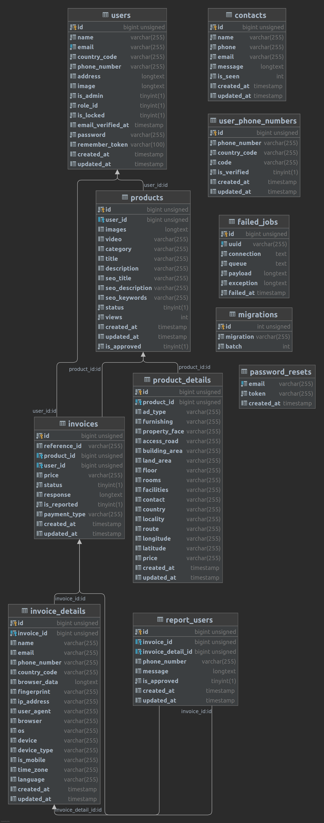

Figure 8:Class and Object Diagram

## 5.3 Use Case Diagram

A use case diagram is a picture that shows how a person can interact with a product or system in different ways. An oval form is used to show what the use situation is. The people involved in the process are shown as stick figures, and their role in the system is shown by a line that goes from the player to the use case. The user is the most important part of the system because he or she is the one who uses it. The user is the main player, and the third-party database that verifies the user's sign-up and log-in is the secondary actor, which in this system is called "admin." The person fills out and sends in the registration form. On click, the manager verifies that it is real. If the user's information is correct, the user can see the home screen. If the information is wrong, the user is sent back to the home page. The steps that a person can take are shown in the use case diagram below.

Figure 9: Use Case Diagram

## 5.4 Data Flow Diagram

A data flow diagram (DFD) can be employed to illustrate the data flow of any given process or system. The representation of inputs, outputs, storage locations, and pathways is achieved through the utilization of pre-established symbols such as rectangles, circles, and arrows, accompanied by concise textual annotations. Data flowcharts can range from rudimentary hand-drawn outlines of a process to intricate multi-tiered data flow diagrams (DFDs) that provide progressively detailed information on the handling of data at each level. These tools have the potential to be utilized for either the analysis of systems or the creation of models. A Data Flow Diagram (DFD) possesses the ability to effectively communicate complex information that may be challenging to articulate through language. Furthermore, it has the capacity to convey this information in a manner that is comprehensible to individuals with varying levels of technical proficiency. Hence, Data Flow Diagrams (DFDs) continue to be extensively employed in contemporary times. Interactive, real-time, or database-centric systems are becoming less prevalent despite their efficacy in facilitating the visualization of data flow systems.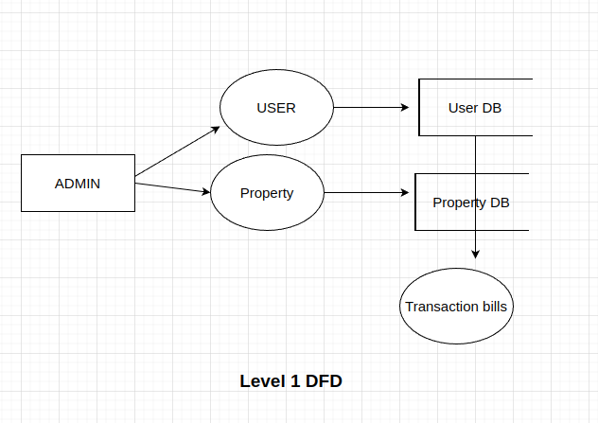

Figure 10: Data Flow Diagram

## 5.5 Context Diagram

A context diagram describes the relationships between an internal software system and its external environment. Its primary function is to aid companies in understanding a system's full breadth. This allows them to determine the optimal parameters for a brand-new system's design, or to enhance an existing one. Because of their higher level of abstraction, context diagrams avoid showing implementation specifics. Instead, they lay out the framework for the whole system in a form that everybody can grasp.For instance, arrows depict the flow of information from the system to each external component. Whether you're a seasoned programmer or a total technophobe, you'll have no trouble grasping the system's functionality.

Several advantages can be attributed to a Context Diagram:

1.This feature provides a comprehensive overview of a system's extent and limitations, encompassing its interconnections with other interfacing systems.

2.The diagram is designed to be comprehensible without any prerequisite technical expertise.

3.The limited notation of this drawing system allows for ease of creation and modification.

4.The system's expandability can be facilitated by incorporating various tiers of Data Flow Diagrams (DFDs).

5.The potential beneficiaries of this initiative encompass a broad spectrum of individuals, including stakeholders, business analysts, data analysts, and developers.

Figure 11: Context Diagram

## 5.6 ER Diagram

When people refer to a "ERD," they usually mean a "entity relationship diagram." Some people sometimes refer to these kinds of diagrams as "Entity Relationship Models" or "ER diagrams." An entity relationship diagram (ERD) is a graphical representation of the relationships between entities in a database, such as people, things, or concepts. A common feature of ERDs is the visualization of the properties associated with the entities being modeled. The Entity Relational Model (ERM) is a conceptual model utilized for the identification of entities that are to be represented within a database, as well as for the representation of the relationships that exist between said entities. The ER data model delineates the enterprise schema, which graphically portrays the comprehensive logical framework of a database. The Entity Relationship Diagram (ERD) elucidates the interrelationships that exist among the various entities that are contained within a given database. Entity-relationship (ER) models are utilized to represent tangible entities such as individuals, automobiles, or corporations, as well as the associations between these entities in the actual world. To put it succinctly, an ER Diagram serves as the structural representation of a database. The logical structure of databases can be represented through an Entity Relationship (ER) diagram, which involves the identification of entities, the display of their attributes, and the illustration of the relationships that exist between them. This resource may prove useful for engineers seeking to either document an extant database in its present state or outline the architecture of a novel database.

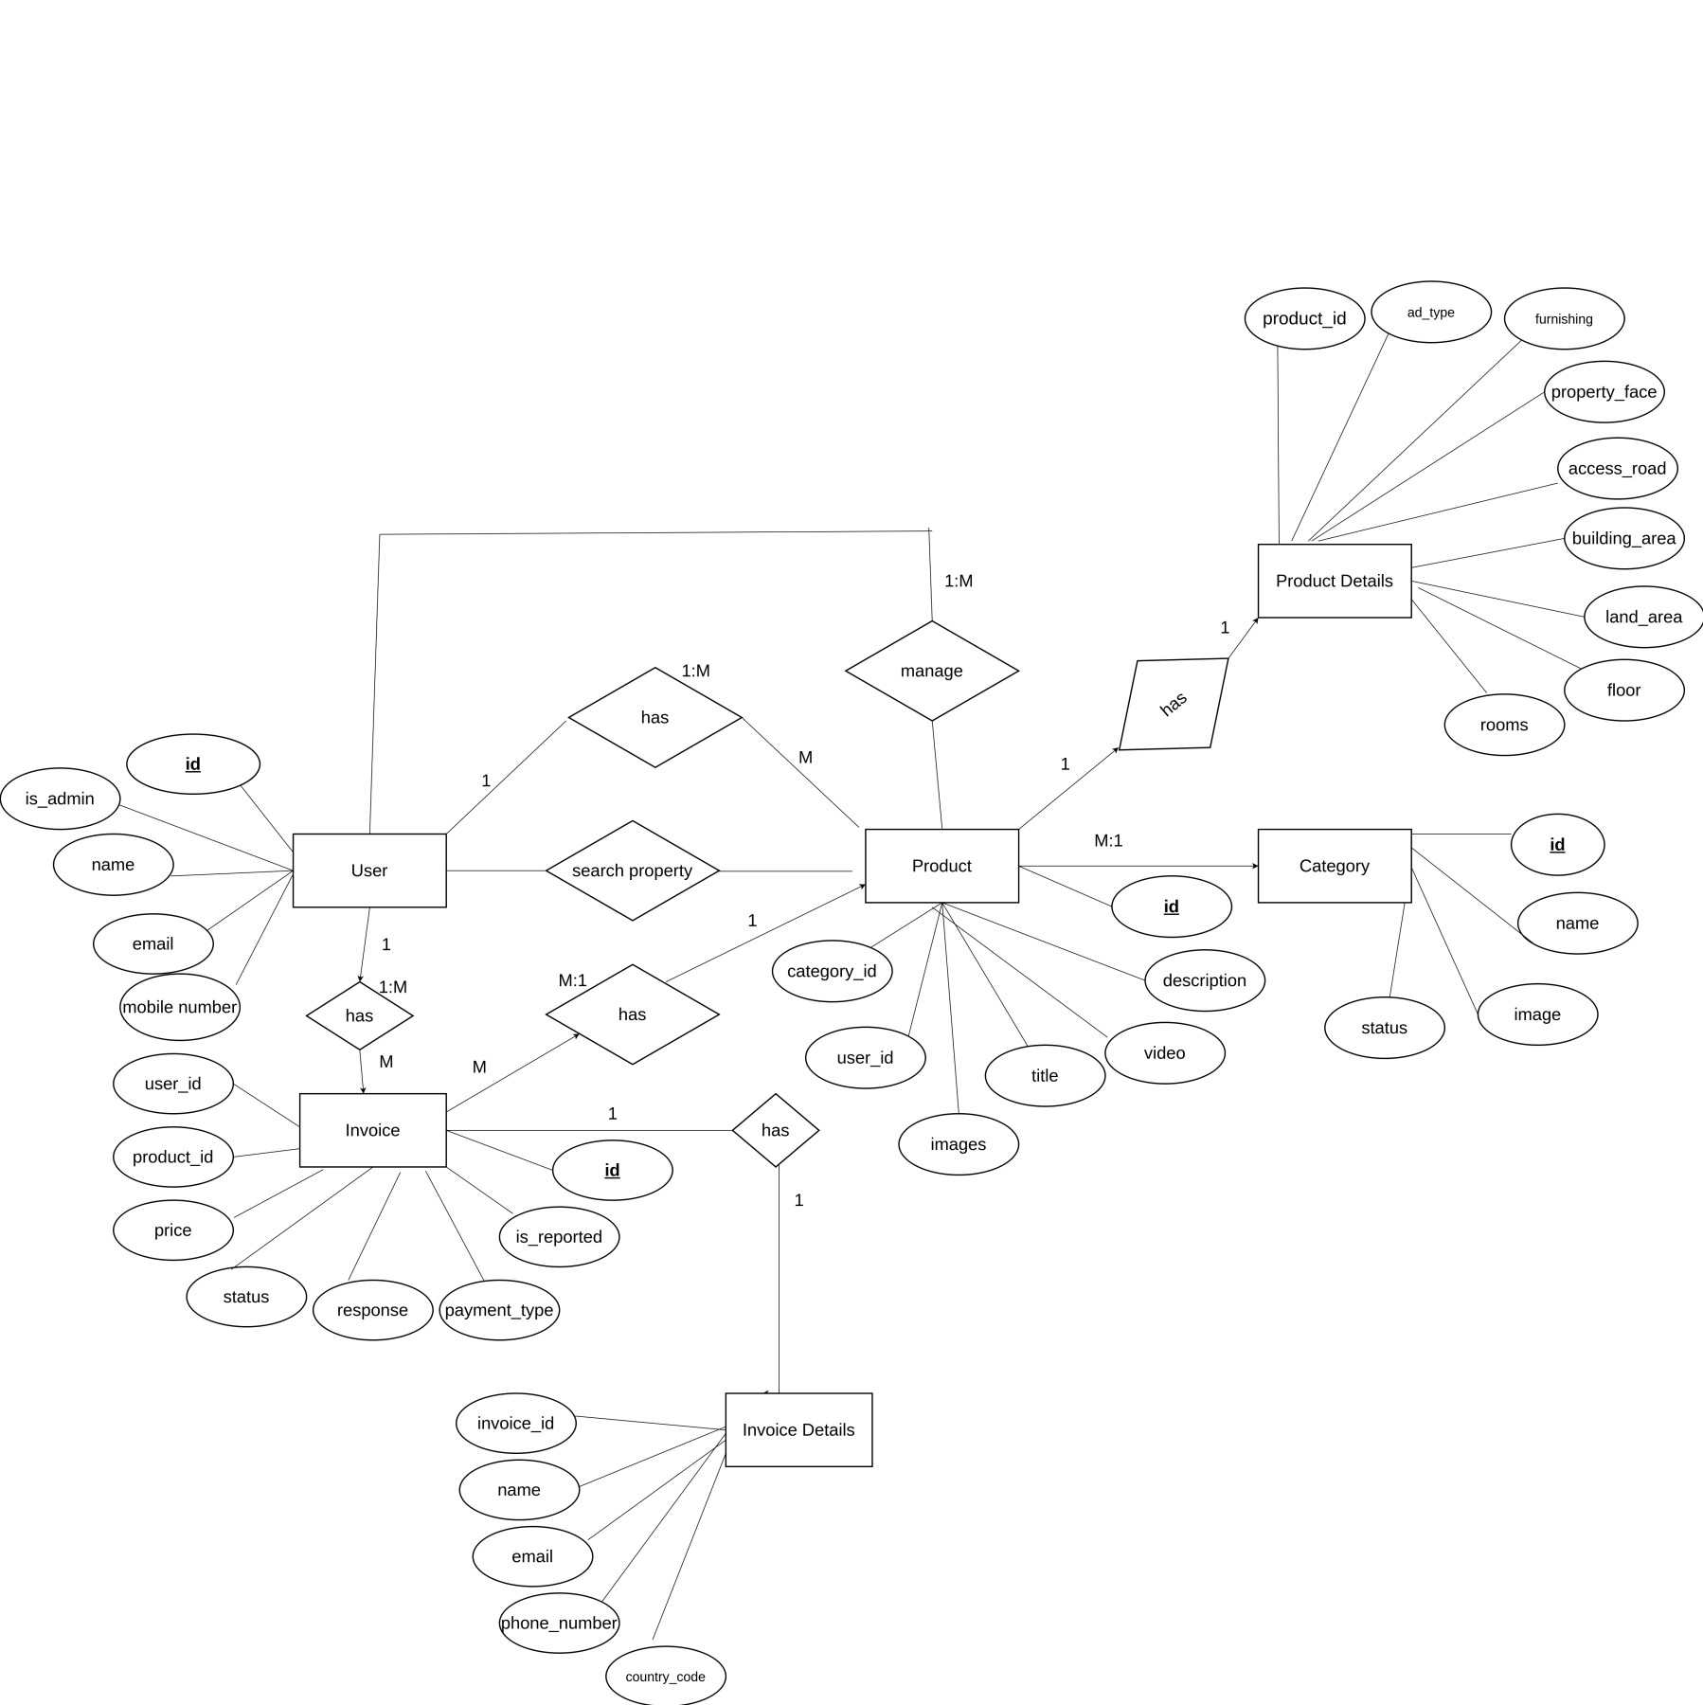

Figure 12: ER Diagram

# 6. System Requirements Analysis

Requirement analysis refers to the process that occurs at the commencement of product development and entails establishing, documenting, and managing a set of requirements. The process involves information accumulation and service specification. It's simple to learn (Simplilearn, 2022). One way to figure out what features a new product must have is to conduct a requirements analysis, sometimes called requirements engineering. This analysis focuses on the needs and prerequisites for a new product. If the software's developers need to veer off course from the original intent, they can refer back to the requirement analysis for guidance. Each company faces the formidable task of trying to convince its potential customers that it has the right idea for a final product. Therefore, in order to do a requirements analysis, it is necessary for the product's major stakeholders, such as software engineers, end-users, and customer managers, to work together. This is a normal first step in any endeavor, as it guarantees that the final product will be up to snuff. Functional and non-functional needs are the two main outputs of a requirement analysis. The four-step MoSCoW method helps determine which project needs should be prioritized in order to generate the highest return on investment (ROI). MoSCoW is an abbreviation for "must have," "should have," "could have," and "will not have;" the o's make it easier to say. The MoSCoW framework is used in many different areas of business. It helps everyone on the team prioritize tasks and understand how doing so will affect the project's bottom line, whether that be through a rise in income, a drop in expenses, more output, or happier customers. In the corporate world, it helps facilitate talks regarding the relative value of different product characteristics while evaluating potential software vendors. When it comes to IT, the MoSCoW approach is crucial to Agile project management since it aids teams in setting priorities for story points. Additionally, prioritizing requirements helps project teams comprehend the time and energy needed for completing various aspects of the project. The team's time management, the project's manageability, the possibility of finishing by the deadline, and the return on investment (ROI) can all benefit from this information. Several names have been given to the MoSCoW approach: MoSCoW analysis, MoSCoW prioritization, the MoSCoW procedure, and the MoSCoW rules. System requirement analysis was also performed on this project, with the same results. The following follows the MoSCoW framework for discussing these findings:

## 6.1 Functional Requirement

Since 1999 (Malan & Bredemeyer) Functional requirements describe the desired operation of the system. The functional requirements of a system are those that the end user identifies as necessary capabilities. These are stated as input to the system, operations to be performed, and desired results. The project's functional needs are as follows:

Table 1: Functional Requirement

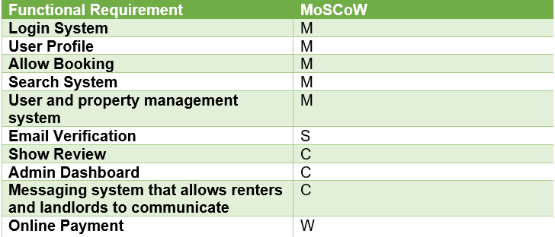

## 6.2 Non-Functional Requirement

Non-functional requirements refer to the quality criteria that a system must satisfy to fulfill the project contract. The significance of these aspects, as well as their degree of application, may differ across projects. Non-behavioral requirements is another term used to describe non-functional requirements. The non-functional requirements for this project are outlined below:

Table 2:Non-Functional Requirement

## 6.3 Feasibility Analysis

This research is used to decide whether or not a project should be initiated. After the viability of the project has been established. We can now proceed with the project's finalized requirements and specification. There are three factors that will be taken into account throughout the feasibility study. They constitute:

1.Economic Feasibility:

Financial gain to the company is the focus of this initiative. The most common approach to gauging the efficacy of a new suggested system is a cost/benefit analysis. And most importantly, it's going to be put to use in a suggested study.

2.Technical Feasibility:

The system relies entirely on freely accessible, open-source software and hardware. The system meets the technological requirements for storing the data necessary to conduct the analysis of sentiment. The current implementation is only the groundwork for future enhancements that will make the system even more powerful.

3.Operational Feasibility:

How well a project will be able to back any operation or service during the operational phase is how "operational feasibility" is determined. The value of a proposed project is contingent on its viability as a system for actual application. It is possible to model the system for use on other platforms.

4.Schedule Feasibility:

The term "schedule feasibility" refers to the possibility that a project will be finished on time. The completion of this system is on time.

5.Gantt Chart:

A Gantt chart is a visual representation of a project's schedule used in project management. There is usually a list of things that need to be done on the left, and a timeline with scheduling bars on the right. Task durations, major and minor completion points, interdependencies, and responsible parties can all be displayed in a Gantt chart.

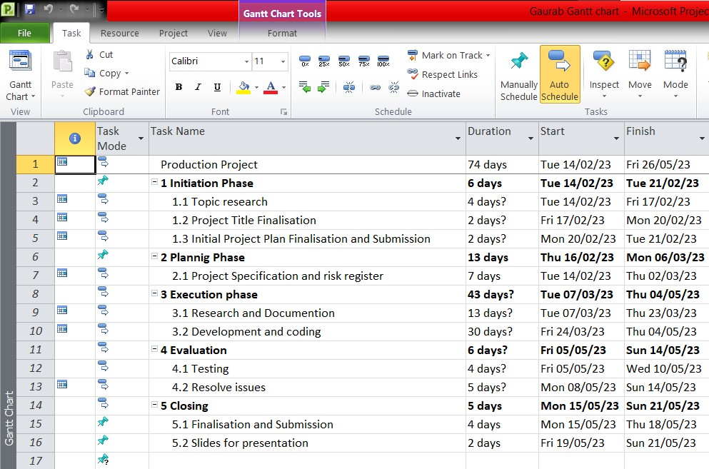

Figure 13:Gantt Chart

Figure 14: Timeline

# 7.Implementation and Testing

## 7.1 Implementation

For the implementation first we need to install Nodejs, Xampp and Composer

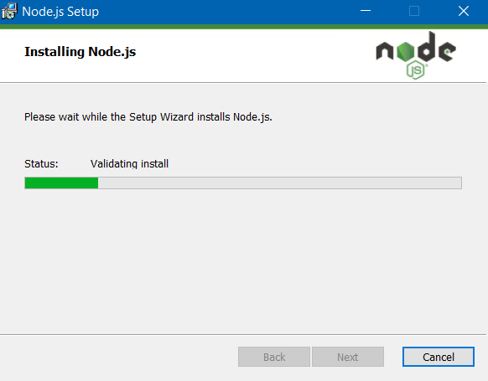

Figure 15: Installation of NodeJS

Figure 16: Installation of Xammp

Figure 17: Installation of Composer

Figure 18: Installation of Laravel

Figure 19: Installation of VueJs

HTML, Cascading Style Sheets (CSS), and JavaScript are the three primary languages that are utilized while developing websites by web developers. JavaScript is the language that is used for programming, HTML is what we use to build the site, and CSS is what we use to style and layout the web page. So, using these tools we implement the code and make the interface and website work properly.

Also, Implementation details of modules are explained below:

1.Registration Module:

This Modules helps to sign up a new user for the web application and stores the data the user enters in MYSQL. It helps to give the user access to the web service. It also checks to see if the user is already in the database or not. This makes sure that no two people with the same name are in the same web application.

Operation provided by this model system are:

* Add record ()
* check record ()
* has pass ()

2.Login/logout Module:

This Module helps you sign in to or sign out of a web application that requires you to enter the information you gave on the signup form. If the record entered matches the record in the database, the user will be taken to the home page of the application. If the record entered doesn't match the record in the database, the user will be taken to the login page. The user won't be taken to the home page of the application until the record entered matches the record in the database. And the info you enter will also be saved in the session. When you click "Log Out," you'll be taken to the login page, and the session data that was saved while you were logged in will be lost.

Operational provided by this model system are:

* login user ()
* logout user ()
* session user ()
* destroy session ()
* check_hash_password ()
* check record ()

3.User Management Module

This Module helps manage the different users of the system by taking safe steps to protect data. It also gives users the ability to change their MYSQL-stored posts, usernames, passwords, and emails. Using different buttons that have been coded with different questions and tasks for the user to make things easier.

Operation provided by this model system are:

* add post ()
* delete post ()
* update post ()
* update email ()
* update pass ()
* update_uname ()

## 7.2 Testing

Testing is done to make sure that the software tool or product meets both business and user needs. It is very important to have a good test coverage in order to test the software application thoroughly and make sure it works as expected. Testing can be used for proof, validation, or figuring out how reliable something is. The following are some of the goals of software testing:

• To check whether software is built. It is as per the requirement or not.

• Finding defects from the software before customers find them out.

• Defects get fix from the developer.

• Preventing defects.

• Gaining confidence about the level of quality.

1.Signup page:

Table 3:Signup Page

|  |  |
| --- | --- |
| Objectives | To enter the record of the user for the login purpose. |
| Action | The input section should be filled with the Full Name, Username, Email, and the Password should be hidden. |
| Excepted Results | To enter all the data correctly which stores the data into the database and pressing the signup button should redirect to the login page. |
| Actual Results | All user data is inserted into the input field and all data is stored into the database and the button redirects to the login page. |
| Conclusion | Test Successful. |

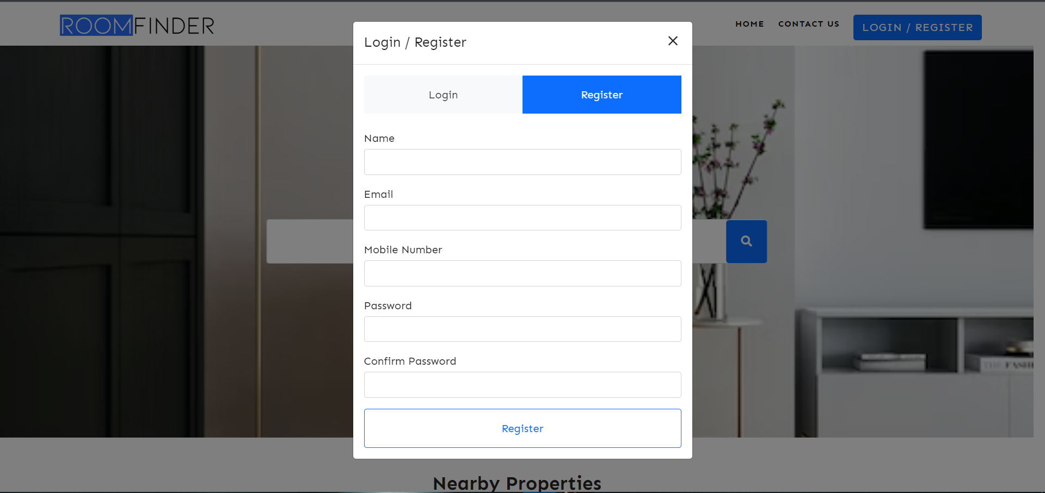

Figure 20:Signup Page

2.Login Page:

Table 4:Login Page

|  |  |
| --- | --- |
| Objectives | To enter the record of the user to enter the main page of the project. |
| Action | Enter the user email and password, pressing the login button leads to the main page. |
| Excepted Results | To enter the Email and Password of the user and if the email and password matched in the database then login to the main page. |
| Actual Results | The email and password are verified and entered into the main page. |
| Conclusion | Test Successful. |

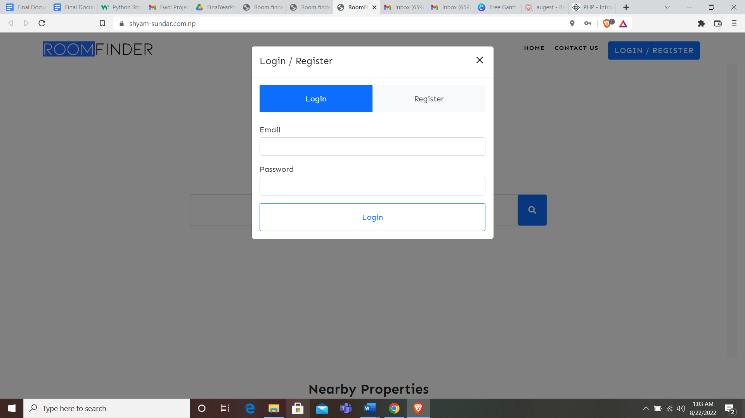

Figure 21:Login Page

3.Contact us:

Table 5:Contact Us

|  |  |
| --- | --- |
| Objectives | To show the contact us page of the project. |
| Action | Clicking the side navbar to go to the about page. |
| Excepted Results | To contact with us for the inquires for the information |
| Actual Results | The page is shown. |
| Conclusion | Test Successful. |

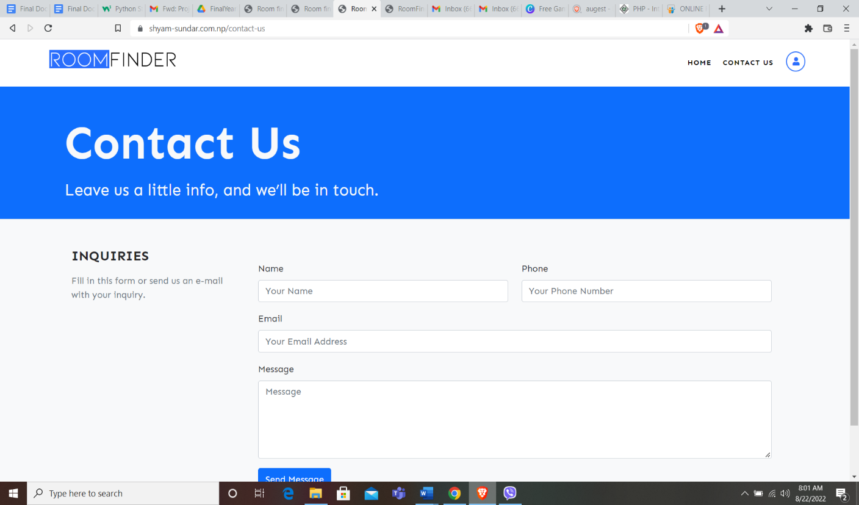

Figure 22:Contact Us

4.Logout

Table 6:Logout

|  |  |
| --- | --- |
| Objectives | To get out of the web application |
| Action | Clicking the logout on the side navbar. |
| Excepted Results | To go to the login page while clicking the logout page. |
| Actual Results | While pressing the button it leads the user to the login page and also destroys all the sessions stored while processing. |
| Conclusion | Test Successful. |

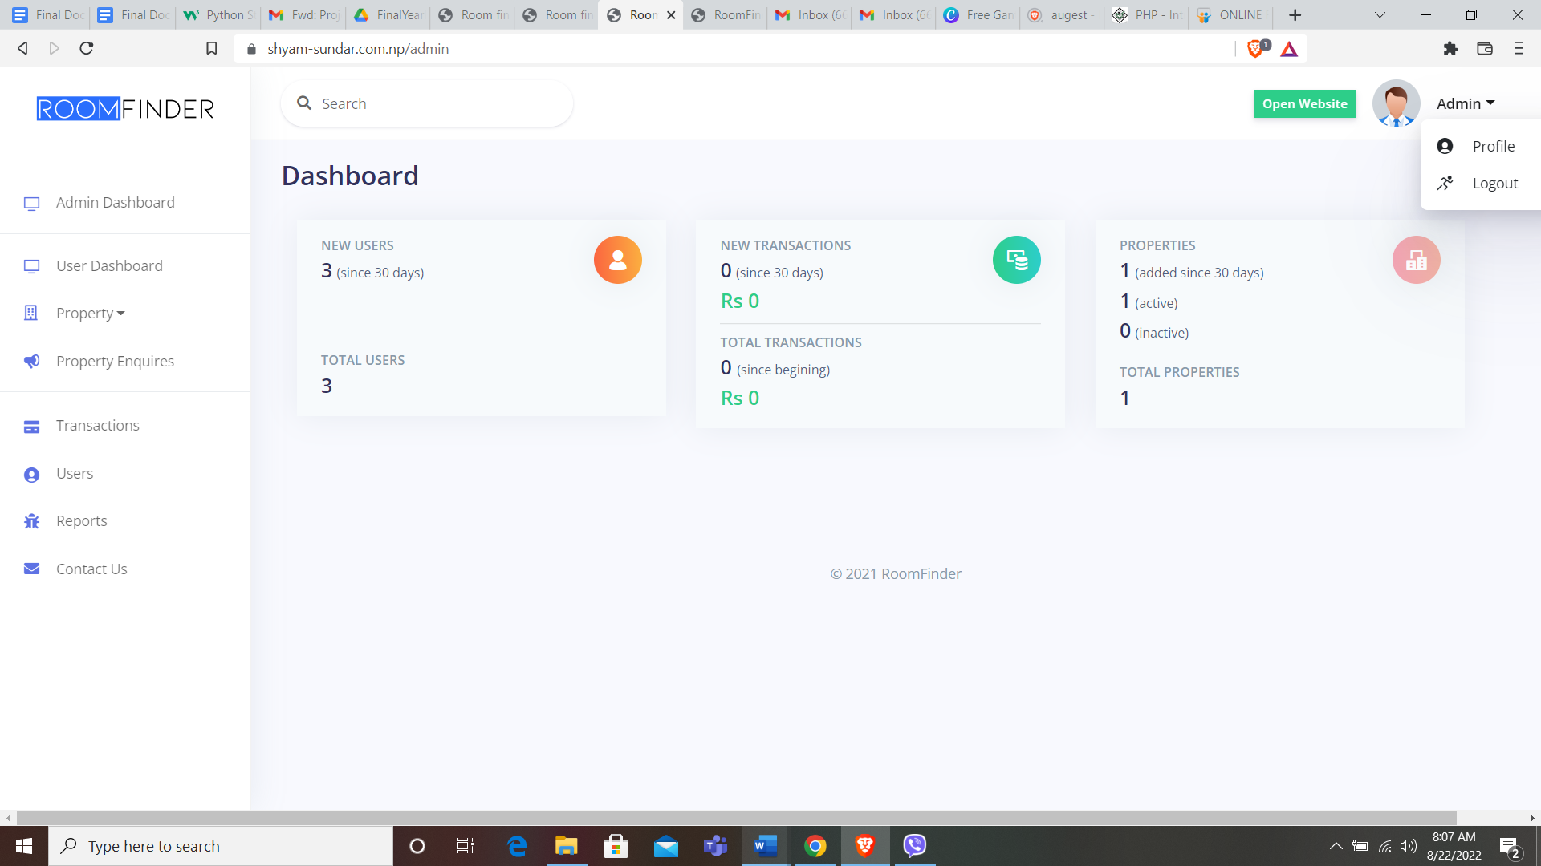

Figure 23:Logout

## 7.3Test case for System Testing

System testing is the process of testing the whole, fully functional system to make sure it meets all of the client's needs, which are written down in the functional specification or system specification documentation. Most of the time, it's done right after Integration testing, since that testing should cover how the whole system works. So, the System Testing is broken up into two parts:

1.Alpha Testing

Your application is ready for release to the public when it passes the final round of testing, known as alpha testing, conducted by your quality assurance (QA) team. Your own test team manages, organizes, and does the majority of the testing. The primary goal of alpha testing is to guarantee flawless operation.

This testing is done meticulously to ensure that there are no flaws. Several issues were discovered throughout the process and addressed. Some kinks still need to be ironed out. There are certain issues that need fixing, such as annoying pop-ups and missing. Comments on otherwise encouraging data. We're working hard to iron out the kinks. However, the system's performance is unaffected by the issues. hence, we can declare that it is ready for public consumption.

2.Beta Testing

During beta testing, the program is made available to a select group of people who really use it. They are free to apply any use they see fit to it. To put it another way, this testing is not structured in any way. On the other hand, the users are strongly urged to provide comments regarding the operation of the program. During these tests, you should also be monitoring how well the backend is working, as a matter of course. The performance and scalability of the product are the primary focuses of beta testing.

Therefore, in order to do the beta testing, we have provided a select group of our friends with access to the beta project for a period of one week. After that period, we will solicit feedback from the actual users. The user interface, as well as the color coordination, is done extremely effectively, and the workflow is unobstructed. In addition, the feedback they have been receiving has been entirely favorable, which indicates that the project is succeeding in meeting its objectives. The only problem is that the project has issues, so when users add material—even stuff that is positive—the data is not collected by the program. This is the only issue with the project. However, after the issues have been fixed, the program is excellent in terms of the positive content it provides and is an excellent fit for the real-world project.

# 8.Product Evaluation

Throughout the course of the website development life cycle, the prototype of the website was put through continuous testing. In general, it was successful in all of the tests that were performed on it. The following is a list of some of the functional and nonfunctional requirement tests, together with their expected and final findings of the product that was produced, which demonstrates how the product is evaluated:

The research provides an in-depth investigation of the question of how to construct a safe and efficient platform by utilizing VueJS and Laravel to develop a website that helps people find rooms or apartments to rent. It highlights the benefits of each framework as well as the potential ways in which they can work together. The article describes the basic components that such a platform needs to include, such as search filters, payment mechanisms, tools for managing users and properties, as well as review and rating systems. In addition to this, it places an emphasis on the necessity of scalability, maintainability, and responsiveness when it comes to the development process for a website.

However, the study is somewhat lengthy, and in some places further material and expanded explanation would be beneficial. For instance, it may go into deeper detail on the specific challenges involved in establishing a website that allows users to look for rooms or apartments, as well as how the VueJS and Laravel frameworks might assist in this endeavor. It is also possible that any potential drawbacks or limits related with the implementation of these frameworks will be discussed.

The research provides an excellent introduction to the idea of utilizing VueJS and Laravel to construct a room/flat locator website as a whole; nevertheless, it may benefit from additional detail and specificity in a few spots.

# 

# 9.Project Evaluation

Microsoft Project allows users to construct schedules and plans for their projects, as well as manage resources and track the passage of time (Keupp, 2022). MS Project provides access to a variety of useful tools, including Gantt charts, Kanban boards, and project calendars, for management professionals. This instrument can be used for preliminary project planning, resource management, and timesheets.The development of a program is one factor that is considered when analyzing a project. Acquiring and analyzing data on a program's activities, characteristics, and outcomes are also required steps in this process. As a direct consequence of this, a timeline or a Gantt chart was developed in order to illustrate the workflow of various tasks while the project was in various stages. The following illustration provides a high-level summary of the activities that must be completed in order to bring this project to a timely conclusion.

Figure 24: Task sheet

Figure 25:Timeline for my project

# 10.Summary and Conclusions

In addition to this, the program makes the claim that it would provide users with a mobile system that is easy, reliable, and useful to clients. This is an additional claim made by the application. People require specific places to reside in order to work or study, and the population is expanding at a steady rate every day. As a result, by developing a website that enables users to simply access or obtain information about a variety of properties that are available for rent and acquire such properties according to their requirements. Users will have the ability to filter and find their ideal hotel utilizing the website's user-friendly and effective search system, which is based on location, price, facilities, and other preferences the user may have. The purpose of this project is to achieve the goal of providing a platform that is dependable and user-friendly, with the intention of simplifying the rental process for occupants as well as landlords. By the time this project is finished, one of our goals is to have established a website that is both comprehensive and easy to use as a room or apartment finder. This will make the process of renting easier and more accessible to everyone. When it comes to the creation of a room or flat finder website, the usage of the VueJS and Laravel frameworks provides a very efficient and secure solution that has the potential to fulfill the requirements of both tenants and landlords. By integrating powerful features and ensuring mobile responsiveness, scalability, and maintainability, the platform may provide a user experience that is both straightforward and aesthetically pleasing. This may make it possible for the platform to streamline the lease process for all parties involved.

# Bibliography

[1] Publiser: IEEE, Analysis and design of house management system based on B/S, 2021[Online]. Available: ieeexplore.ieee.org

[2] Laravel. (2022). Retrieved from https://laravel.com/

[3] VueJS. (2022). Retrieved from https://Vuejs.org/

[4] Bhardwaj, A. (2021). Building a Room/Flat Finder Web Application with VueJS and Laravel. Retrieved from https://www.c-sharpcorner.com/article/building-a-room-flat-finder-web-application-with-Vuejs-and-laravel/

[5] Alen, M. (2021). How to build a room/flat rental platform using VueJS and Laravel. Retrieved from <https://flatlogic.com/blog/how-to-build-a-room-flat-rental-platform-using-vuejs-and-laravel/>

[6] M. a. Kyrin’s, HTML, CSS, and JavaScript All in One, pristone, 2000.

[7] RICHARD H. THAYER, Software project management, 2015.

[8] ROGER PRESSMAN, Software engineering, 2018

[9] MATT STUAFFER, Laravel: Up and Running: A Framework for Building Modern PHP Apps 1st Edition, 2013.

[10] MG MARTIN, PHP: Advanced Detailed Approach to Master PHP Programming Language for Web Development Paperback – June 24, 2019.

[11] TONY AMADI, Property Management system, 2018 [Online]. Available: academic.edu.

[12] Publiser: IEEE, Analysis and design of property management system based on B/S, 2021 [Online]. Available: ieeexplore.ieee.org

[13] MySQL Reference Manualby Michael Widenius, David Axmark, Kaj ArnoReleased June 2002 Publisher(s): O'Reilly Media, Inc.ISBN: 9780596002657

[14] JavaScript Pocket Referenceby David FlanaganReleased October 1998Publisher(s): O'Reilly Media, Inc.ISBN: 9781565925212

[15] "PropTech 101: Turning Chaos into Cash through Real Estate Innovation" by Aaron Block and Zach Aarons, "The Future Is Smart: How Your Company Can Capitalize on the Internet of Things

[16] "The Airbnb Story: How Three Ordinary Guys Disrupted an Industry, Made Billions

[17] Win in a Connected Economy" by W. David Stephenson

[18] The International and Comparative Law Quarterly, Vol. 19, No. 2 (Apr., 1970), pp. 205-216

[19] Journal of Housing and the Built Environment, Vol. 33, No. 4 (December 2018), pp. 653-673

# Appendices

## Website Screenshots

## Meeting logs

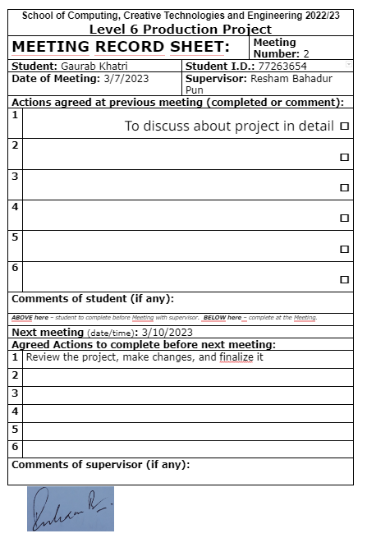

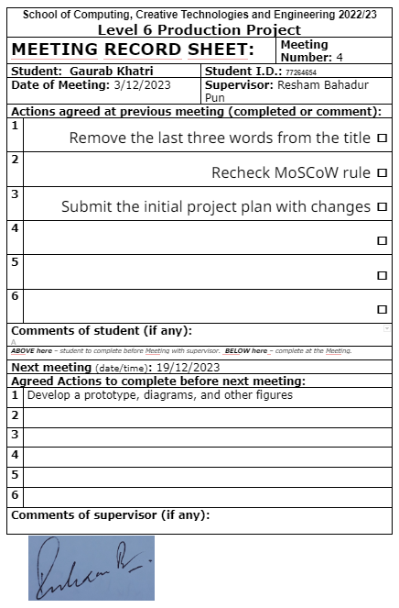

## Ethical Consent Form

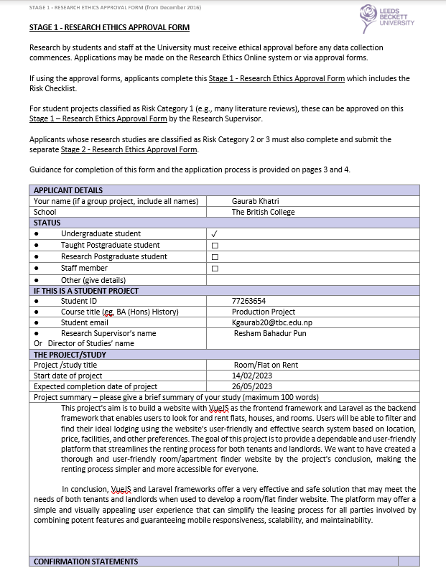

## Risk Register

